# Context Management System

By Victor Besson

Table of Contents

Context Management System 1

Business Model 2

High Level System Requirements 3

Entity Relational Diagram 4

Data Dictionary 5

Objectives and User Cases 6

Considerations 9

Constraints 10

Business Model

My context management system ‘GachiBase’ business model is a system that allows users to create content such as posts which are relatable to a thread on Reddit where users can also make comments or a forum and pages which are a simulation of a webpages. This system also allows users to communicate to each other in the form of whispers allowing two users the ability to send each other private messages, this can keep user retention because it allows the system to potentially be more active. Overall with all these features the system has the potential to hold and create a large active community of users. This system can also be well moderated by its admins allowing them to delete inappropriate posts, pages, comments, as well as banning users who might break policy.

# High Level System Requirements

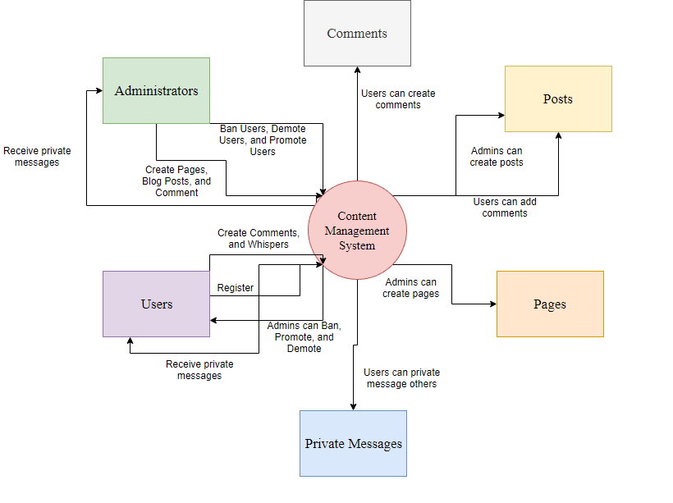

# Entity Relational Diagram

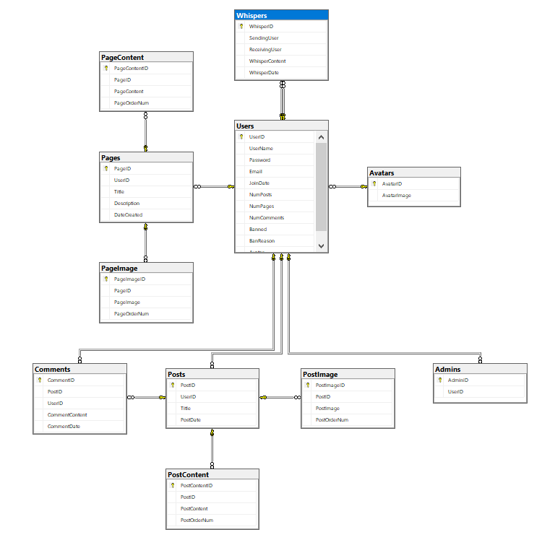

# Data Dictionary

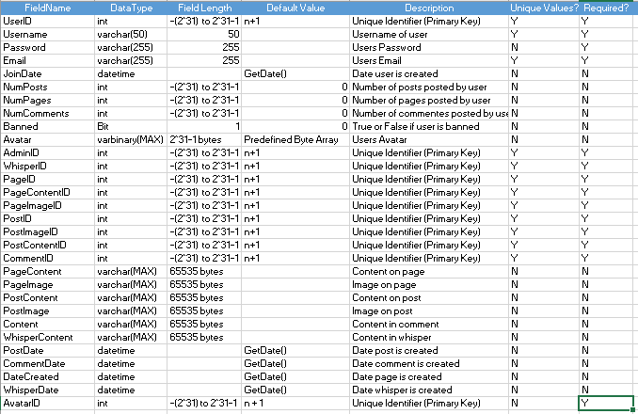

# Objectives and User Cases

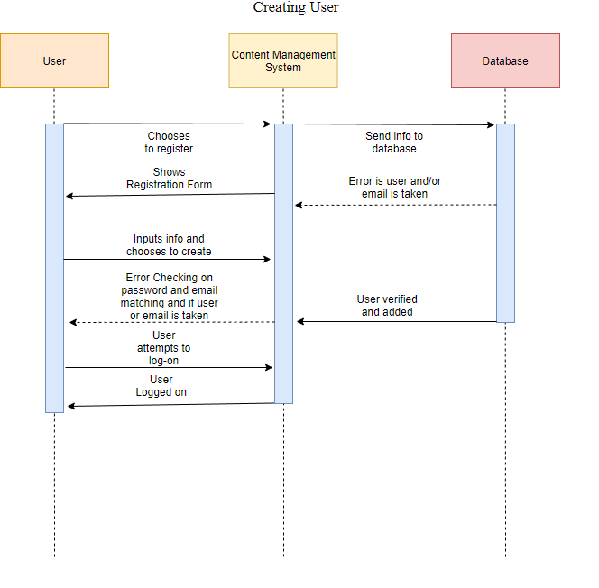

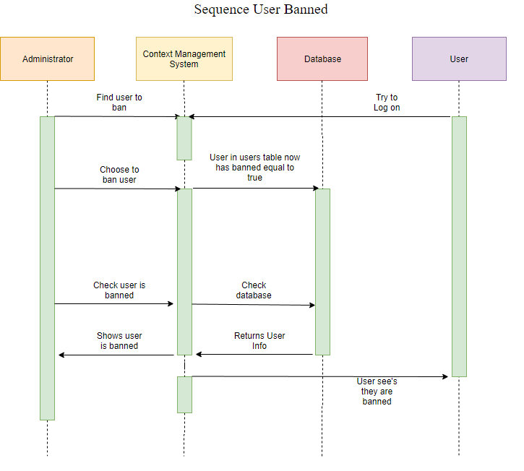

DFD for creating page

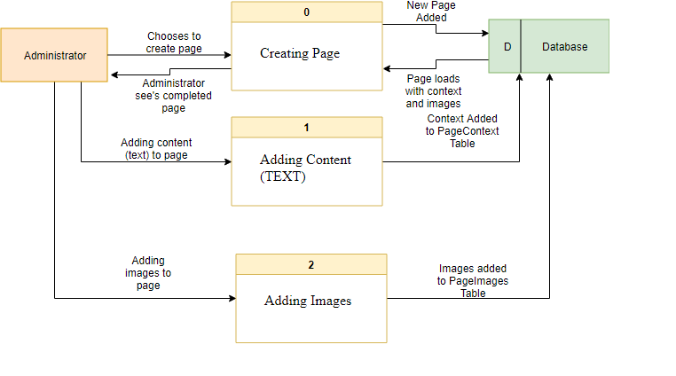

Class Diagram

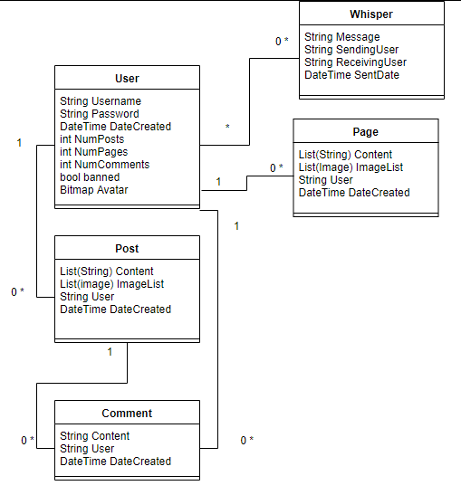

# Considerations

Some of the consideration for GachiBase would be size of the blog and if the database and server is reliably fast enough for the amount of information the blog can potentially have in the future, when and how would user’s be trusted to be administrators and if they can be trusted not to demote current administrators or promote untrustworthy user’s, the ability to stop user’s from intentionally spamming comments on posts or whispers to other user’s, the user’s being able to evade bans by using a fake email or email generating site and creating new accounts indefinitely, stopping users from opening up more than one use of the application at a time to counter spamming or ‘botting’.

# Constraints

The constraints of the GachiBase would be: Time to get everything that is mandatory completed, the reliability of the database and size of the database, the users to follow the rules of the blog, possible integration of future endeavors and added features, how the blog looks and its design, that the blogs users follow the law and admins delete comments and potentially banning users who would say something that would break it.

System Acceptance Criteria

The criteria for the system to be accepted and ready for deployment would be:

Having two levels of users (Administrator and User).

Allowing the administrator to:

Ban users, promote and demote users, create blog posts, create blog pages, and delete comments, posts, and pages.

Allowing the users to:

Register, post comments on posts, send private messages to users and administrators, view profile information of any user.

The blog should be able to run on any windows 10 machine.

The blog should be able to automatically be able to connect to its database if needed.